**MEASURING THE PULSE OF PROSPERITY: AN INDEX OF ECONOMIC FREEDOM ANALYSIS**

**PROJECT REPORT**

1.Introduction

**Economic freedom, or economic liberty, is the ability of people of a society to take economic actions. This is a term used in economic and policy debates as well as in the philosophy of economic.**

* 1. **overview**

**Individuals have economic freedom when property they acquire with our the use of force ,fraud, or theft is protected from physical invasions by others and they are free to use, exchange, or give their property as long as their actions do not violate the identical tights of others.**

* 1. **Purpose**

**Economic freedom means that people can engage in trade with any person of their choosing. If the government taxes or otherwise prevents people from buying or selling with people in other countries, it reduces their freedom**

2 .Problem Definition & Design Thinking

**2.1 Empathy Map**

**An empathy map is a template that organizes a user’s behaviours and feelings to create a sense of empathy between the user and your team.**

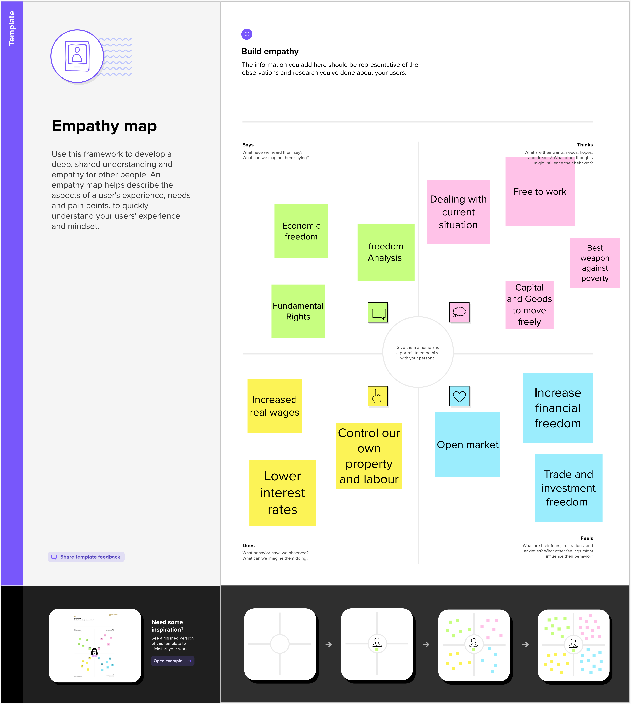

 **2.2 Ideation & Brainstorming map**

3. Result

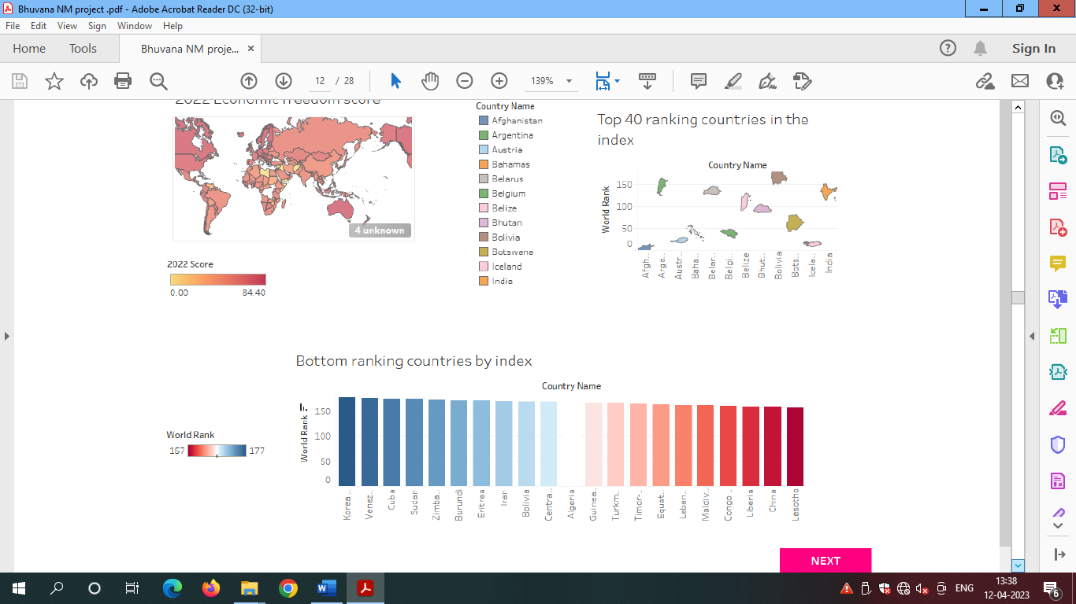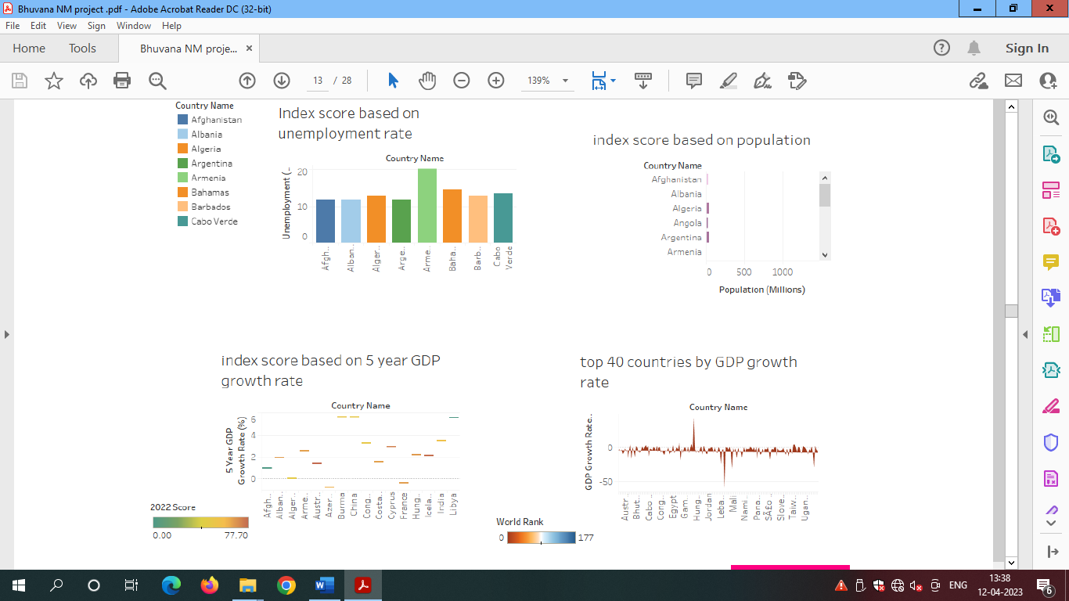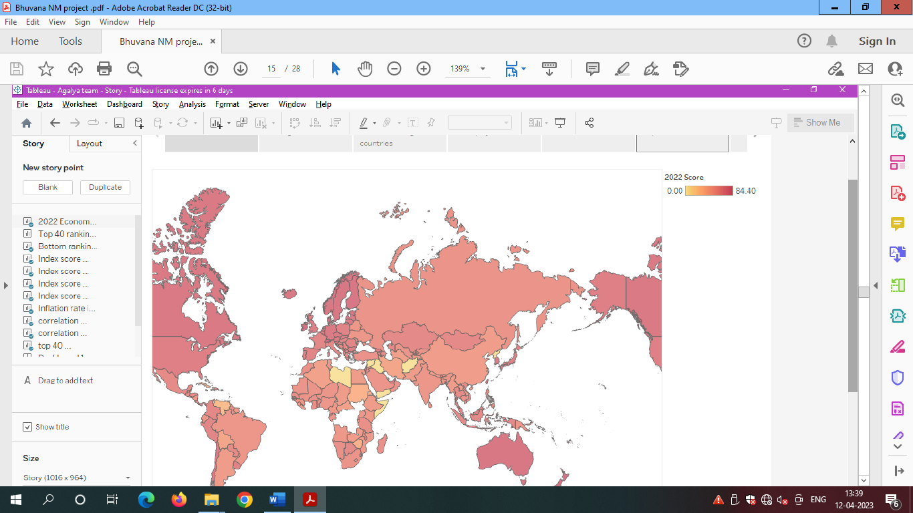

4.ADVANTAGES:

* **The Conducive The most obvious benefit of economic freedom is that, as a system, it is the most to widespread prosperity, that is, to high or rising income and consumption for the bulk of the population.**
* **A market economy promotes free competition among market participants. Notable benefits of a market economy are increased efficiency, production, and innovation.**

DISADVANTAGES:

* **Poor Quality. Since profit maximization is the biggest motivation for firms, they may try to reduce their costs unethically.**
* **Merits Goods. Goods and services that are not profitable will not be produced or run.**
* **Excessive power of firms.**
* **Unemployment and inequality.**

5. APPLICATIONS:

**Individuals have economic freedom when property they acquire without the use of force, fraud, or theft is protected from physical invasions by others and they are free to use, exchange, or give their property as long as their actions do not violate the identical rights of others.**

6. CONCLUSION

* **Economic freedom is the fundamental right of every human to control his or her own labour and property, In a economically free society,**
* **Individuals are free to work, produce, consume and invest in any way they please.**
* **Economic freedom is not easy to achieve.**

7. FUTURE SCOPE

Growth in advanced economics is expected to decline from 5% in 2021 to 3.8% in 2022 and 2.3% in 2023- a pace that, while moderating, will be sufficient to restore output and investment to their pre-pandemic trend in these economics.

8. APPENDIX

**A. Source Code:** Agalya team final project.html